DELIVERY RECORD MANAGEMENT SYSTEM

DATABASE MANAGEMENT SYSTEM PROJECT REPORT

Submitted For
UCS310 – Database Management Systems
B.Tech (2nd Year)
Thapar Institute of Engineering & Technology

Submitted By
- Naina Singh (1024030633)
- Divyansh Arora (1024030635)

Submitted To
Gayatri Saxena
(Lab Instructor – 2C45)

Academic Session
2025–2026

CERTIFICATE
This is to certify that the project report entitled “Delivery Record Management System” submitted by Naina Singh and Divyansh Arora in partial fulfillment of the requirements for the subject Database Management Systems (UCS310) is a bonafide work carried out under the guidance of the concerned faculty during the academic session 2025–2026.
The work presented in this report has not been submitted elsewhere for any other degree or certification.
Faculty Signature: ____________________
Date: ____________________

ACKNOWLEDGEMENT
We would like to express our sincere gratitude to our DBMS faculty and lab instructor, Ms. Gayatri Saxena, for her valuable guidance, encouragement, and continuous support throughout the development of this project.
We also thank Thapar Institute of Engineering & Technology for providing us with the opportunity and resources to work on this project. This project helped us gain practical understanding of database design, normalization, SQL queries, PL/SQL programming, and transaction management concepts.
Finally, we are thankful to everyone who directly or indirectly contributed to the successful completion of this project.

ABSTRACT
The Delivery Record Management System is a database-driven application developed to manage and organize delivery operations efficiently. The system stores and maintains records related to customers, delivery agents, orders, assignments, payments, and complaints in a centralized database.
The project focuses on implementing core Database Management System concepts such as Entity Relationship modeling, relational schema design, normalization, SQL operations, PL/SQL programming, triggers, cursors, procedures, and transaction management.
The system eliminates redundancy, improves data consistency, enables faster retrieval of records, and supports automated backend operations. It also provides reporting and tracking functionalities that help manage delivery operations effectively.
The project demonstrates the practical application of DBMS concepts in solving real-world logistics and delivery management problems.

TABLE OF CONTENTS
- Introduction
- Problem Statement
- Objectives of the Project
- Scope of the Project
- Proposed System Description
- System Architecture
- Database Design
- ER Diagram
- Relational Schema
- Normalization
- SQL Implementation
- PL/SQL Components
- Transaction Management
- Sample Queries
- Expected Outcomes
- Conclusion
- Future Enhancements
- References

1. INTRODUCTION

1.1 What is a Delivery Record Management System?
A Delivery Record Management System is a database-based application that manages delivery operations and related records in a structured manner. It stores customer details, order records, delivery agent information, payment details, and delivery tracking data.
The system helps organizations maintain accurate records, reduce manual work, improve operational efficiency, and ensure reliable delivery tracking.

1.2 Motivation Behind the Project
With the rapid growth of e-commerce and courier services, delivery companies process thousands of orders daily. Managing these records manually becomes difficult and error-prone.
This project was selected to understand how real-world logistics systems use databases for:
- Managing customer records
- Tracking deliveries
- Assigning delivery agents
- Handling payments
- Generating reports
- Maintaining data consistency

1.3 Importance of DBMS in Delivery Systems
Traditional manual systems often result in:
- Duplicate entries
- Data inconsistency
- Delayed updates
- Payment errors
- Inefficient record handling
A Database Management System provides:
- Centralized storage
- Faster data retrieval
- Data security
- Multi-user access
- Reduced redundancy
- Better transaction management
- Improved operational efficiency

2. PROBLEM STATEMENT
Delivery companies manage a large amount of data every day including customer information, delivery records, agent details, and payment transactions.
Manual or spreadsheet-based systems face several problems such as:
- Redundant data storage
- Difficulty in updating delivery status
- Improper agent assignment
- Delayed tracking information
- Lack of centralized database management
- Increased chances of human error
The proposed Delivery Record Management System solves these problems using a relational database model with SQL and PL/SQL operations.

3. OBJECTIVES OF THE PROJECT
The major objectives of this project are:
- To design an efficient database for delivery management
- To implement Entity Relationship modeling techniques
- To convert ER models into relational tables
- To apply normalization up to 3NF/BCNF
- To perform CRUD operations using SQL
- To automate tasks using PL/SQL procedures and triggers
- To ensure data consistency using constraints
- To generate useful reports using SQL queries
- To understand practical DBMS implementation

4. SCOPE OF THE PROJECT

4.1 Operational Scope
The project focuses on backend database implementation for delivery operations.
The system manages:
- Customer records
- Order details
- Delivery agents
- Assignments
- Payment details
- Complaints
- Delivery reports

4.2 User Access

Administrator
- Manages database records
- Updates system information
- Generates reports
- Handles complaints

Delivery Agents
- View assigned deliveries
- Update delivery status
- Track assigned orders

Customers
- Customer records are maintained by admin
- Order details and complaint records are stored

4.3 Core Modules
- Customer Management
- Order Management
- Delivery Agent Management
- Assignment Management
- Payment Management
- Complaint Management
- Report Generation

5. PROPOSED SYSTEM DESCRIPTION
The proposed system uses a centralized relational database to manage all delivery-related information.
The workflow includes:
- Customer places an order
- Order details are stored in database
- Delivery agent is assigned
- Payment details are processed
- Delivery status is updated
- Reports are generated for monitoring

Main Features
- Centralized data storage
- Delivery tracking
- Automated assignment handling
- Payment management
- Complaint management
- Report generation
- Data consistency and integrity

6. SYSTEM ARCHITECTURE

Input Layer
- Customer details
- Order details
- Payment information
- Delivery status updates

Database Layer
The database contains normalized tables:
- CUSTOMER
- DELIVERY_AGENT
- ORDER_DETAILS
- ASSIGNMENT
- PAYMENT
- COMPLAINT

Processing Layer
The system performs:
- SQL queries
- Data retrieval
- Data modification
- PL/SQL automation
- Report generation

Output Layer
- Delivery reports
- Revenue reports
- Assignment details
- Payment status reports

7. DATABASE DESIGN

7.1 Entities

CUSTOMER
Stores customer information.
Attributes:
- Customer_ID
- Name
- Contact_No
- Email
- Address
- City
- Pincode

DELIVERY_AGENT
Stores delivery agent details.
Attributes:
- Agent_ID
- Name
- Contact_No
- Vehicle_Type
- Area_Assigned
- Joining_Date

ORDER_DETAILS
Stores order-related information.
Attributes:
- Order_ID
- Customer_ID
- Order_Date
- Delivery_Address
- Order_Value
- Delivery_Status

ASSIGNMENT
Stores delivery assignment details.
Attributes:
- Assignment_ID
- Order_ID
- Agent_ID
- Assigned_Date
- Delivery_Time
- Delivery_Status

PAYMENT
Stores payment records.
Attributes:
- Payment_ID
- Order_ID
- Payment_Mode
- Payment_Status
- Transaction_ID

COMPLAINT
Stores complaint records.
Attributes:
- Complaint_ID
- Order_ID
- Customer_ID
- Complaint_Type
- Resolution_Status

8. ER DIAGRAM

Relationships
- One Customer can place multiple Orders (1:M)
- One Order is assigned to one Delivery Agent (M:1)
- One Order has one Payment (1:1)
- One Order can have multiple Complaints (1:M)

ER Diagram Note
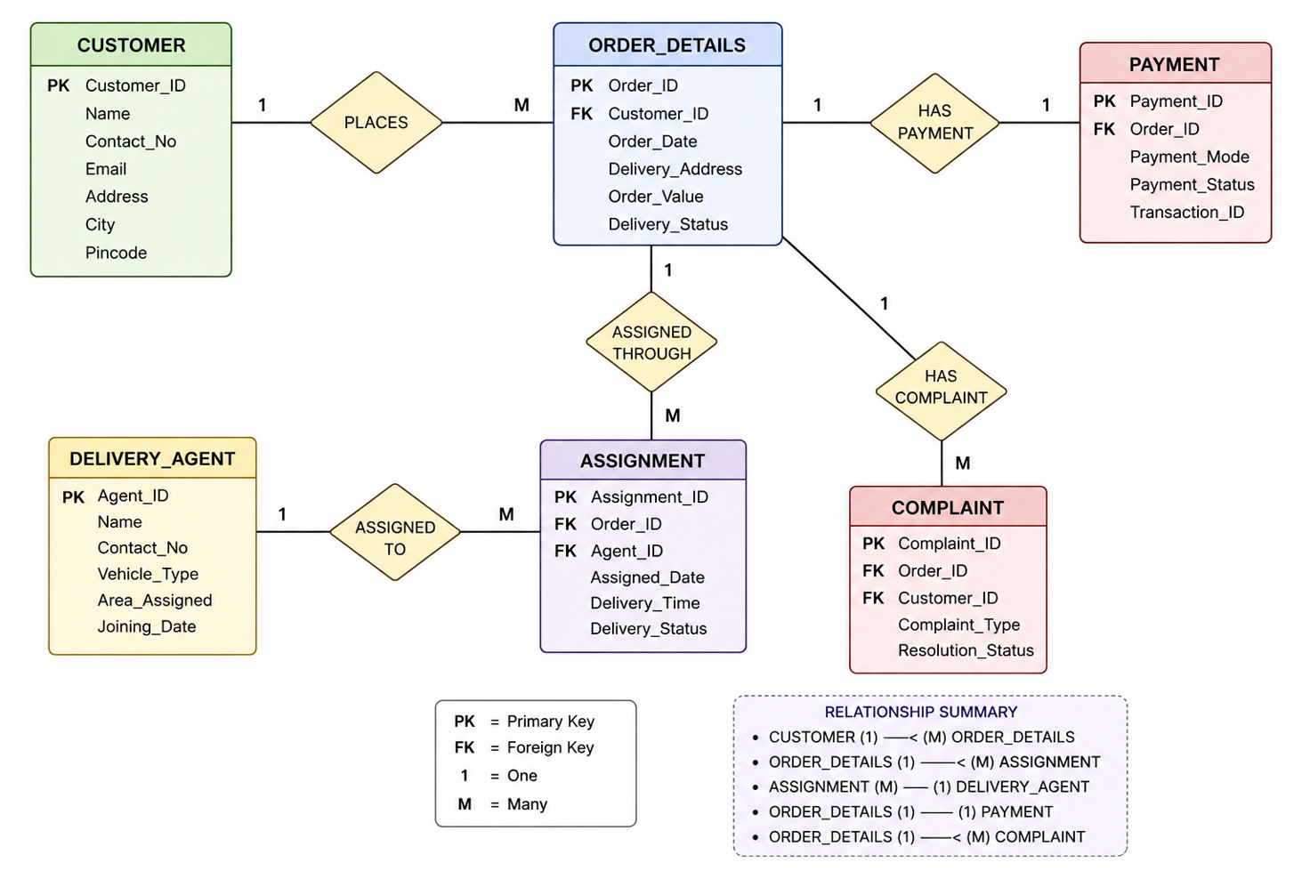

9. RELATIONAL SCHEMA

CUSTOMER
(Customer_ID, Name, Contact_No, Email, Address, City, Pincode)

DELIVERY_AGENT
(Agent_ID, Name, Contact_No, Vehicle_Type, Area_Assigned, Joining_Date)

ORDER_DETAILS
(Order_ID, Customer_ID, Order_Date, Delivery_Address, Order_Value, Delivery_Status)

ASSIGNMENT
(Assignment_ID, Order_ID, Agent_ID, Assigned_Date, Delivery_Time, Delivery_Status)

PAYMENT
(Payment_ID, Order_ID, Payment_Mode, Payment_Status, Transaction_ID)

COMPLAINT
(Complaint_ID, Order_ID, Customer_ID, Complaint_Type, Resolution_Status)

Primary Keys
- Customer_ID
- Agent_ID
- Order_ID
- Assignment_ID
- Payment_ID
- Complaint_ID

Foreign Keys
- Customer_ID references CUSTOMER
- Order_ID references ORDER_DETAILS
- Agent_ID references DELIVERY_AGENT

10. NORMALIZATION

Functional Dependencies
- Customer_ID → Name, Contact_No, Email, Address, City, Pincode
- Agent_ID → Name, Contact_No, Vehicle_Type, Area_Assigned, Joining_Date
- Order_ID → Customer_ID, Order_Date, Delivery_Address, Order_Value, Delivery_Status
- Payment_ID → Order_ID, Payment_Mode, Payment_Status, Transaction_ID

First Normal Form (1NF)
- All attributes contain atomic values
- No repeating groups exist

Second Normal Form (2NF)
- Every non-key attribute fully depends on the primary key
- No partial dependencies exist

Third Normal Form (3NF)
- No transitive dependencies exist
- Separate tables are maintained for related entities
The database is normalized up to Third Normal Form.

11. SQL IMPLEMENTATION

DDL Commands

Create CUSTOMER Table
CREATE TABLE CUSTOMER (
Customer_ID INT PRIMARY KEY,
Name VARCHAR(100),
Contact_No VARCHAR(15),
Email VARCHAR(100),
Address VARCHAR(200),
City VARCHAR(50),
Pincode VARCHAR(10)
);

Create DELIVERY_AGENT Table
CREATE TABLE DELIVERY_AGENT (
Agent_ID INT PRIMARY KEY,
Name VARCHAR(100),
Contact_No VARCHAR(15),
Vehicle_Type VARCHAR(50),
Area_Assigned VARCHAR(100),
Joining_Date DATE
);

Create ORDER_DETAILS Table
CREATE TABLE ORDER_DETAILS (
Order_ID INT PRIMARY KEY,
Customer_ID INT,
Order_Date DATE,
Delivery_Address VARCHAR(200),
Order_Value DECIMAL(10,2),
Delivery_Status VARCHAR(50),
FOREIGN KEY (Customer_ID)
REFERENCES CUSTOMER(Customer_ID)
);

DML Commands

Insert Data
INSERT INTO CUSTOMER
VALUES (101, 'Naina Singh', '9876543210',
'naina@gmail.com', 'Patiala', 'Patiala', '147001');

Update Query
UPDATE ORDER_DETAILS
SET Delivery_Status = 'Delivered'
WHERE Order_ID = 201;

Delete Query
DELETE FROM COMPLAINT
WHERE Complaint_ID = 301;

12. PL/SQL COMPONENTS

Stored Procedures
Procedures automate backend tasks such as:
- Agent assignment
- Order processing
- Delivery updates
- Report generation

Example Procedure
CREATE OR REPLACE PROCEDURE Update_Status(
oid IN NUMBER,
status IN VARCHAR2)
IS
BEGIN
UPDATE ORDER_DETAILS
SET Delivery_Status = status
WHERE Order_ID = oid;
END;

Functions
Functions calculate:
- Total revenue
- Total completed deliveries
- Orders assigned to agents

Triggers
Triggers automatically perform operations such as:
- Updating order status after payment
- Preventing duplicate assignments
- Maintaining integrity constraints

Cursors
Cursors process multiple records while generating reports.

Exception Handling
Exception handling manages invalid inputs and runtime errors.

13. TRANSACTION MANAGEMENT

COMMIT
Saves successful transactions permanently.

ROLLBACK
Restores previous database state during errors.

SAVEPOINT
Allows partial rollback within a transaction.

ACID Properties

Atomicity
Transactions complete fully or not at all.

Consistency
Database remains valid after each transaction.

Isolation
Multiple users can access data safely.

Durability
Committed data remains permanently stored.

14. SAMPLE QUERIES

Display All Customers
SELECT * FROM CUSTOMER;

Display Delivered Orders
SELECT * FROM ORDER_DETAILS
WHERE Delivery_Status = 'Delivered';

Total Revenue Generated
SELECT SUM(Order_Value) AS Total_Revenue
FROM ORDER_DETAILS;

Display Orders with Customer Names
SELECT C.Name, O.Order_ID, O.Delivery_Status
FROM CUSTOMER C
JOIN ORDER_DETAILS O
ON C.Customer_ID = O.Customer_ID;

Agent-wise Delivery Count
SELECT Agent_ID, COUNT(*) AS Total_Deliveries
FROM ASSIGNMENT
GROUP BY Agent_ID;

15. EXPECTED OUTCOMES
The project is expected to achieve the following:
- Efficient management of delivery records
- Reduced data redundancy
- Improved data consistency
- Better delivery tracking
- Automated backend operations
- Faster report generation
- Improved transaction management
- Practical understanding of DBMS implementation

16. CONCLUSION
The Delivery Record Management System successfully demonstrates the practical implementation of Database Management System concepts in a real-world scenario.
The project provides centralized storage and efficient management of customer records, delivery information, payments, and complaints. By applying normalization, constraints, SQL queries, PL/SQL procedures, triggers, and transaction management, the system ensures consistency, integrity, and efficient data processing.
This project helped in understanding the importance of databases in logistics and delivery operations and provided practical exposure to relational database design and implementation.

17. FUTURE ENHANCEMENTS
The system can be enhanced further by adding:
- Frontend user interface
- Real-time GPS tracking
- Mobile application support
- AI-based delivery optimization
- Online payment gateway integration
- Email/SMS notifications
- Dashboard analytics
- Authentication and role-based access
- Cloud database deployment

18. REFERENCES
- Database System Concepts – Abraham Silberschatz
- Oracle SQL Documentation
- MySQL Documentation
- PL/SQL Programming Guide
- DBMS course notes and lab manuals
- Online SQL and database tutorials

APPENDIX

Tools Used
- Oracle DBMS / MySQL
- SQL Developer / MySQL Workbench
- SQL and PL/SQL

Technologies Used
- Relational Database Management System
- SQL
- PL/SQL
- ER Modeling
- Normalization Techniques

NOTE
This report is based on the proposed Delivery Record Management System project and may undergo minor modifications during implementation and testing phases.

